JUnit Testing

# Validation Class – validation functions:

|  |  |  |  |  |
| --- | --- | --- | --- | --- |
| **Test no.** | **Test** | **Expected Result** | **Actual Result** | **Pass/**  **Fail** |
| 1 | Testing validateUsername() method with a valid username. | A true result should be returned. | “Username is valid.” Was printed to the console indicating a true result was returned. | PASS |
| 2 | Testing validateUsername() method with no value. | A false result should be returned. | “Username is empty.” Was printed to the console indicating a false result was returned. | PASS |
| 3 | Testing validateUsername() method with a username already on the system. | A false result should be returned. | “Username is already used.” Was printed to the console indicating a false result was returned. | PASS |
| 4 | Testing validatePassword() method with a valid password. | A true result should be returned. | “Password is valid.” Was printed to the console indicating a true result was returned. | PASS |
| 5 | Testing validatePassword() method with a blank value. | A false result should be returned. | “Password is empty.” Was printed to the console indicating a false result was returned. | PASS |
| 6 | Testing validateName() method with a valid password. | A true result should be returned. | “Name is valid.” Was printed to the console indicating a true result was returned. | PASS |
| 7 | Testing validateName() method with a blank value. | A false result should be returned. | “Name is not valid.” Was printed to the console indicating a false result was returned. | PASS |
| 8 | Testing validateName() with numbers. | A false result should be returned. | “Name is not valid.” Was printed to the console indicating a false result was returned. | PASS |
| 9 | Testing validateAddress() method with a blank value. | A false result should be returned. | “Address is empty.” Was printed to the console indicating a false result was returned. | PASS |
| 10 | Testing validateAddress() method with a valid address. | A true result should be returned. | “address is valid.” Was printed to the console indicating a true result was returned. | PASS |
| 11 | Testing validatePhone() with a valid phone number. | A true result should be returned. | Test passed. | PASS |
| 12 | Testing validatePhone() with only 5 digits. | A false result should be returned. | Test passed. | PASS |
| 13 | Testing validatePhone() with a blank value. | A false result should be returned. | Test Passed. | PASS |

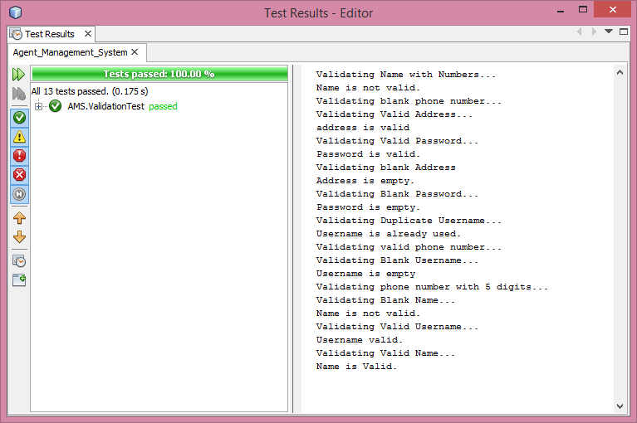

# Create ticket controller – checkdate function

|  |  |  |  |  |
| --- | --- | --- | --- | --- |
| **Test no.** | **Test** | **Expected Result** | **Actual Result** | **Pass/**  **Fail** |
| 1 | Test checkDate() function with a future date. | A true result will be returned. | A true result was returned. | PASS |
| 2 | Test checkDate() function with a past date(). | A false result will be returned. | A false result was returned. | PASS |
| 3 | Test checkDate() function with todays date. | A true result will be returned. | A false result was returned. | FAIL |

